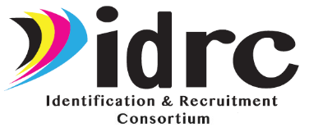
Evaluation Data Checklist
YEAR 3 (2025-26)

√ | Form | Performance  Measures  Addressed | Person(s)  Responsible | Person  Completing | Due Date
 | Form 1: IDRC Director Survey | 1/2/3/4 | St | St | 9/25/26
 | Form 2: IDRC Training Evaluation | 1 | IDRC | St/IDR/MEP | After trainings
 | Form 3: IDRC Meeting Evaluation | 1 | IDRC | St/IDR | After meetings
 | Form 4: IDRC-ID&R Staff Survey | 1/2/3/4 | St | IDR/MEP | 9/25/26
IDRC=IDRC Staff, St=State Directors/Coordinators, IDR=ID&R Staff, MEP=MEP Staff


QR Code/Link to Form 1: IDRC Director Survey
https://www.surveymonkey.com/r/IDRCDirectorSurvey25-26



QR Code/Link to Form 2: IDRC Training Evaluation
https://www.surveymonkey.com/r/IDRCStaffTrainingEval25-26



QR Code/Link to Form 3: IDRC Meeting Evaluation
https://www.surveymonkey.com/r/IDRCMeetingEval25-26


QR Code/Link to Form 4: IDRC-ID&R Staff Survey
https://www.surveymonkey.com/r/IDRC-IDRStaffSurvey25-26

State MEP Directors/Coordinators – Please ensure that all forms listed above
are collected and submitted (or completed online) no later than:
September 25, 2026
Please submit all paper forms to Cari Semivan, META Associates via email at
cari@metaassociates.com
(720) 339-5349

